**Little more on Pointers**

#include "stdafx.h"

#include <iostream>

using namespace std;

int main()

{

int badNums[] = {1,3,5};

int *numPtr = badNums;

cout << "Address: " << numPtr << " Data at this address: " << *numPtr << endl;

numPtr++;

cout << "Address: " << numPtr << " Data at this address: " << *numPtr << endl;

*numPtr++;

cout << "Address: " << numPtr << " Data at this address: " << *numPtr << endl;

return 0;

}

**Result:**

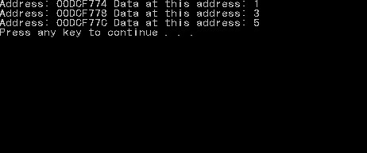

**Important notes:**

* Keep in mind that the pointer shows values when inserted (*), and address without it
* Incrementing both pointers with or without (*) gives the same results